4.1 Introduction
This chapter presents the design and implementation of the proposed School Learning Management System (LMS). It translates the requirements and system analysis presented in Chapter Three into a functional web-based system. The chapter describes the system architecture, use case design, database design, data dictionary, input and output designs, user interface design, system modules, implementation technologies, and testing procedures.
The proposed Learning Management System adopts an API-first architecture in which the frontend communicates with backend services through RESTful API endpoints. The system uses HTML5, CSS3, and JavaScript for the presentation layer, PHP for the backend application and API services, and MySQL for data storage and management. The architecture enables authorised users to interact with academic information and services through a centralised platform.
The chapter also presents the design of the database and the relationships among the major entities that support user management, courses, enrolment, learning materials, assignments, assessments, attendance, results, communication, and other academic activities. The input and output designs describe how information is entered into and retrieved from the system, while the user interface design illustrates the interaction between administrators, teachers, and students and the system.
Finally, the chapter discusses the major modules implemented in the system, the technologies and development tools used, and the testing procedures applied to verify that the system functions according to the specified requirements. The testing process covers individual components, interactions between system components, complete system functionality, and user acceptance. The chapter therefore provides a detailed account of how the proposed LMS was designed, developed, and validated.
4.2 Design of the Proposed System
The proposed School Learning Management System (LMS) was designed to address the limitations identified in the existing academic management system. The design focuses on centralising academic activities, automating routine processes, improving communication among stakeholders, strengthening data security, and providing authorised users with timely access to academic information.
The system adopts a modular and API-first design approach. The frontend provides the user interface through which administrators, teachers, and students interact with the system. Requests from the frontend are sent to the backend through RESTful API endpoints, where authentication, authorisation, validation, and business logic are processed. The backend communicates with the MySQL database to store and retrieve system information, and the results are returned to the frontend in JSON format.
The proposed system provides role-specific functionality. Administrators are responsible for managing users, departments, courses, academic sessions, reports, system settings, and other administrative activities. Teachers can manage their courses, learning materials, assignments, assessments, attendance, grades, and announcements. Students can access enrolled courses, learning materials, assignments, quizzes, attendance information, grades, and notifications.
The design also incorporates security mechanisms to protect academic information and restrict access to authorised users. Authentication and role-based authorisation are applied to ensure that users can access only the functions and information appropriate to their assigned roles. Input validation, secure password storage, prepared database statements, session management, and other security controls are incorporated into the system design.
The proposed system uses a centralised MySQL database to maintain academic and administrative information. The database is structured around related entities that support user management, courses, enrolment, learning materials, assignments, submissions, assessments, attendance, grades, announcements, notifications, and audit activities. This centralised approach reduces data duplication and facilitates efficient retrieval and management of academic information.
Overall, the design of the proposed LMS provides an integrated platform through which academic processes can be managed more efficiently. The architecture, database, modules, interfaces, and security mechanisms described in this chapter form the foundation for the implementation and testing of the proposed system.
4.3 System Architecture
The proposed School Learning Management System adopts a three-layer, API-first architecture consisting of the presentation layer, application/API layer, and data layer. The architecture separates the user interface from the application logic and database, making the system easier to maintain, secure, and extend. Communication between the frontend and backend is handled through RESTful API services using HTTP requests and JSON responses.
4.3.1 Presentation Layer
The presentation layer provides the user interface through which administrators, teachers, and students interact with the system. It is developed using HTML5, CSS3, and JavaScript. The interface provides role-specific dashboards and forms for performing academic and administrative activities.
JavaScript and the Fetch API are used to send requests to the backend REST API without requiring the entire webpage to be reloaded. The presentation layer is responsible for displaying information received from the API and providing appropriate forms and interfaces for user interaction.
4.3.2 Application/API Layer
The application/API layer forms the central processing component of the system. It is implemented using PHP and provides RESTful API endpoints through which the frontend communicates with the backend.
This layer is responsible for:
- User authentication and authorisation.
- Role-based access control.
- Request validation.
- Business logic processing.
- User management.
- Course management.
- Assignment management.
- Learning material management.
- Attendance management.
- Assessment and grading.
- Notifications and communication.
- Report processing.
- Audit and activity logging.
The API receives HTTP requests from the frontend, validates and processes the requests, communicates with the database when necessary, and returns the appropriate response in JSON format. The API architecture separates the frontend from the backend and allows system components to communicate through well-defined endpoints.
4.3.3 Data Layer
The data layer consists of the MySQL database, which provides persistent storage for the information generated and managed by the LMS. The database stores information relating to users, roles, departments, courses, enrolments, learning materials, assignments, submissions, assessments, attendance, grades, announcements, notifications, and system activities.
The data layer is accessed through the backend API rather than directly by the frontend. This separation helps protect the database from direct client-side access and allows database operations to be controlled through the application's authentication, authorisation, validation, and business logic mechanisms.
4.3.4 Communication Flow
Communication between the layers follows a request-and-response model. When a user performs an operation, the frontend sends an HTTP request through the Fetch API to the appropriate RESTful API endpoint. The backend authenticates and authorises the request, validates the submitted data, processes the required business logic, and communicates with the MySQL database where necessary. The database returns the requested information or confirms the requested operation, after which the backend sends a JSON response to the frontend. The frontend then updates the user interface based on the response.
The overall communication flow can be represented as follows:
User → Frontend → Fetch API → PHP REST API → Authentication/Authorisation → Business Logic → MySQL Database → JSON Response → Frontend → Updated Interface
This architecture provides a clear separation of responsibilities between the user interface, application services, and data storage. It also supports maintainability, scalability, security, and the future extension of the Learning Management System.
Figure 4.1 illustrates the system architecture of the proposed Learning Management System.
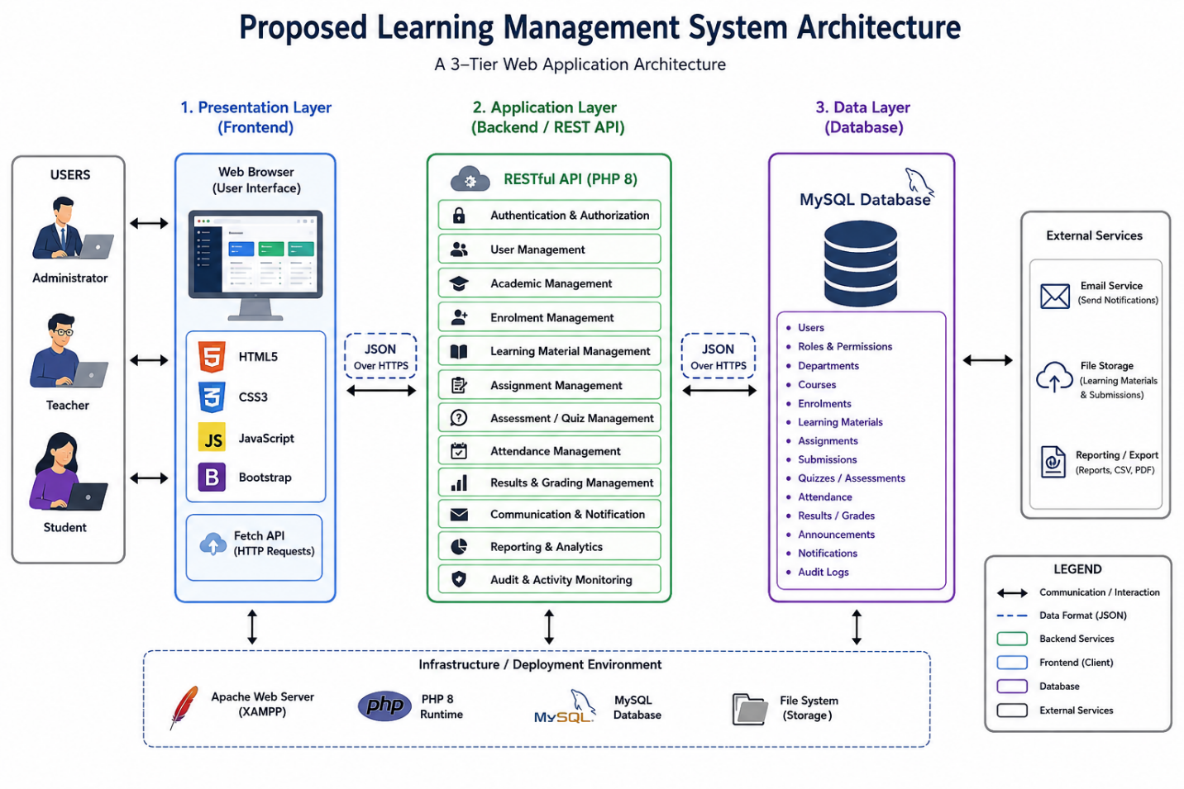
4.4 Use Case Design
The use case design describes the interactions between the users of the proposed School Learning Management System and the functions provided by the system. It identifies the major actors, their responsibilities, and the activities they can perform within the system. The design is based on the functional requirements presented in Chapter Three and focuses on the major roles supported by the proposed LMS.
The principal actors identified for the system are Administrator, Teacher, and Student. Each actor is assigned specific permissions according to their responsibilities within the academic environment. Role-based access ensures that users can access only the functions relevant to their roles.
4.4.1 Administrator
The Administrator is responsible for the overall management and administration of the Learning Management System. The administrator can log into the system, manage user accounts, manage departments and courses, configure academic years or sessions, monitor system activities, generate reports, and manage system settings.
The major administrator uses cases include:
- Login and logout.
- Manage user accounts.
- Manage user roles and permissions.
- Manage departments.
- Manage courses.
- Manage academic years and sessions.
- View and generate academic reports.
- Monitor system activities and audit logs.
- Manage system settings.
- Manage system backup and related administrative functions.
4.4.2 Teacher
The Teacher interacts with the system primarily to manage teaching, learning, assessment, and student academic activities. Teachers can access assigned courses, upload learning materials, create assignments and quizzes, record attendance, assess students, enter grades, and communicate academic information.
The major teacher use cases include:
- Login and logout.
- Access assigned courses.
- Upload and manage learning materials.
- Create and manage assignments.
- Create and manage quizzes.
- Record student attendance.
- Grade assignments and assessments.
- View student performance.
- Publish announcements.
- Communicate with students.
- View relevant academic reports.
4.4.3 Student
The student uses the system to access learning resources and participate in academic activities. Students can access courses in which they are enrolled, view or download learning materials, submit assignments, take quizzes, monitor attendance, view grades, and receive academic notifications.
The major student use cases include:
- Login and logout.
- Access enrolled courses.
- View and download learning materials.
- Submit assignments.
- Take quizzes and assessments.
- View assignment results and grades.
- View attendance information.
- Receive announcements and notifications.
- Access relevant academic information.
4.4.4 Use Case Diagram
The use case diagram illustrates the relationship between the three principal actors and the functions provided by the proposed Learning Management System. The Administrator has system-wide management responsibilities, while the Teacher is primarily concerned with teaching and assessment activities. The student primarily interacts with learning resources, assignments, assessments, attendance, and academic results.
Figure 4.2 presents the Use Case Diagram of the proposed School Learning Management System.
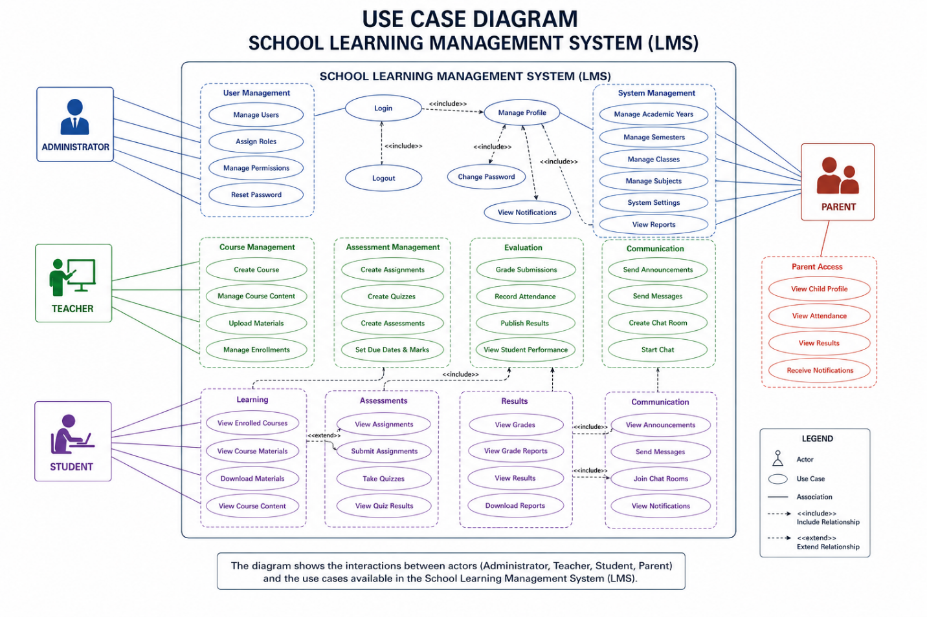

4.4.5 Use Case Description
Use Case | Actor | Description
Login | Administrator, Teacher, Student | Authenticates a user and provides access according to the assigned role.
Manage Users | Administrator | Creates, updates, views, and manages user accounts.
Manage Departments | Administrator | Creates and manages academic departments.
Manage Courses | Administrator, Teacher | Creates, updates, and manages course information according to assigned permissions.
Manage Materials | Teacher | Uploads, updates, and manages learning materials.
Create Assignment | Teacher | Creates assignments and specifies relevant academic requirements and deadlines.
Submit Assignment | Student | Submits completed academic work through the system.
Grade Assignment | Teacher | Reviews student submissions and records grades and feedback.
Manage Quizzes | Teacher | Creates and manages online quizzes and assessments.
Take Quiz | Student | Attempts available quizzes and submits answers for assessment.
Record Attendance | Teacher | Records and manages student attendance for academic activities.
View Grades | Student | Views grades and academic performance information.
Generate Reports | Administrator | Generates academic and administrative reports from stored system data.
Manage Announcements | Teacher, Administrator | Publishes academic or administrative announcements to relevant users.
View Notifications | Teacher, Student | Views system notifications and relevant academic updates.
View Audit Logs | Administrator | Reviews recorded system activities for monitoring and accountability.

The use case design provides a functional representation of how each category of user interacts with the proposed LMS. It also establishes the basis for the subsequent module implementation and testing presented later in this chapter.
4.5 Database Design
The proposed School Learning Management System uses MySQL as its relational database management system. The database was designed to provide a centralised and structured repository for storing, managing, and retrieving academic and administrative information. It supports the major functions of the system, including user management, course management, enrolment, learning materials, assignments, assessments, attendance, results, communication, notifications, and system activity monitoring.
The database design follows a relational approach in which information is organised into related tables. Each table represents a specific entity or functional area of the system, while relationships between tables are established using primary keys and foreign keys. This approach reduces unnecessary duplication of data and supports consistent storage and retrieval of information.
4.5.1 Database Structure
The database is organised into several functional groups that correspond to the major modules of the LMS. These include:
- User and Security Management: stores user accounts, roles, permissions, authentication-related information, and system activity records.
- Academic Management: stores departments, academic years, sessions, courses, and related academic information.
- Enrolment Management: maintains information about students and their enrolment in courses.
- Learning Material Management: stores information about uploaded course materials and their association with courses.
- Assignment Management: manages assignments, submission records, deadlines, grades, and feedback.
- Assessment and Quiz Management: stores quizzes, questions, student attempts, and assessment results.
- Attendance Management: maintains student attendance records for relevant courses and academic activities.
- Results Management: stores student grades, performance records, and related academic results.
- Communication Management: supports announcements, notifications, messages, and other communication activities.
- Audit and Activity Management: records relevant user and system activities for monitoring and accountability.
The relationships among these entities allow information to be shared across different modules without requiring the same information to be repeatedly stored.
4.5.2 Primary and Foreign Keys
Primary keys are used to uniquely identify records within individual tables. For example, a user record is identified by a unique user identifier, while courses, assignments, materials, and submissions have their own unique identifiers.
Foreign keys establish relationships between related tables. For example, a course record can be associated with a teacher or department, while an assignment can be associated with a particular course. Similarly, assignment submissions can be associated with both the relevant assignment and the student who submitted the work.
The use of primary and foreign keys helps maintain referential integrity and ensures that relationships between academic records remain consistent.
4.5.3 Database Normalisation
The database is designed using relational database principles and follows normalisation practices to reduce data redundancy and improve data integrity. The design aims to organise information so that each table represents a logical entity and attributes are stored in appropriate tables.
The database design considers Third Normal Form (3NF), where appropriate, to minimise unnecessary duplication and ensure that non-key attributes depend on the appropriate primary key. This improves maintainability and reduces inconsistencies when records are inserted, updated, or deleted.
4.5.4 Database Relationships
The major relationships within the proposed LMS include:
- A user can have an assigned role that determines the functions available to the user.
- A department can be associated with multiple courses.
- A teacher can manage or be assigned to multiple courses.
- A student can enrol in multiple courses.
- A course can have multiple enrolled students.
- A course can contain multiple learning materials.
- A course can contain multiple assignments and assessments.
- An assignment can have multiple student submissions.
- A student can submit assignments associated with their enrolled courses.
- A course can have attendance records for participating students.
- A student can have multiple academic results and performance records.
- Users can receive announcements and notifications based on their roles and activities.
These relationships provide the foundation for integrating the different academic functions of the LMS.
4.5.5 Database Security
Database security is an important consideration in the design because the system stores sensitive academic and user information. Direct access to the database is restricted to the backend application, while frontend requests are processed through the RESTful API.
Security measures include authentication and authorisation, role-based access control, input validation, prepared SQL statements, secure password storage, and controlled database access. These measures help protect academic records from unauthorised access, manipulation, and accidental loss.
Regular database backup is also considered to support recovery in the event of hardware failure, software errors, or data loss.
4.5.6 Entity Relationship Diagram
The relationships among the major entities of the proposed Learning Management System are represented using an Entity Relationship Diagram (ERD). The ERD provides a graphical representation of the database entities, their attributes, and the relationships between them.
Figure 4.3 presents the Entity Relationship Diagram of the proposed School Learning Management System. The diagram provides the basis for understanding how the major database entities interact and how academic information flows between the different modules of the system.
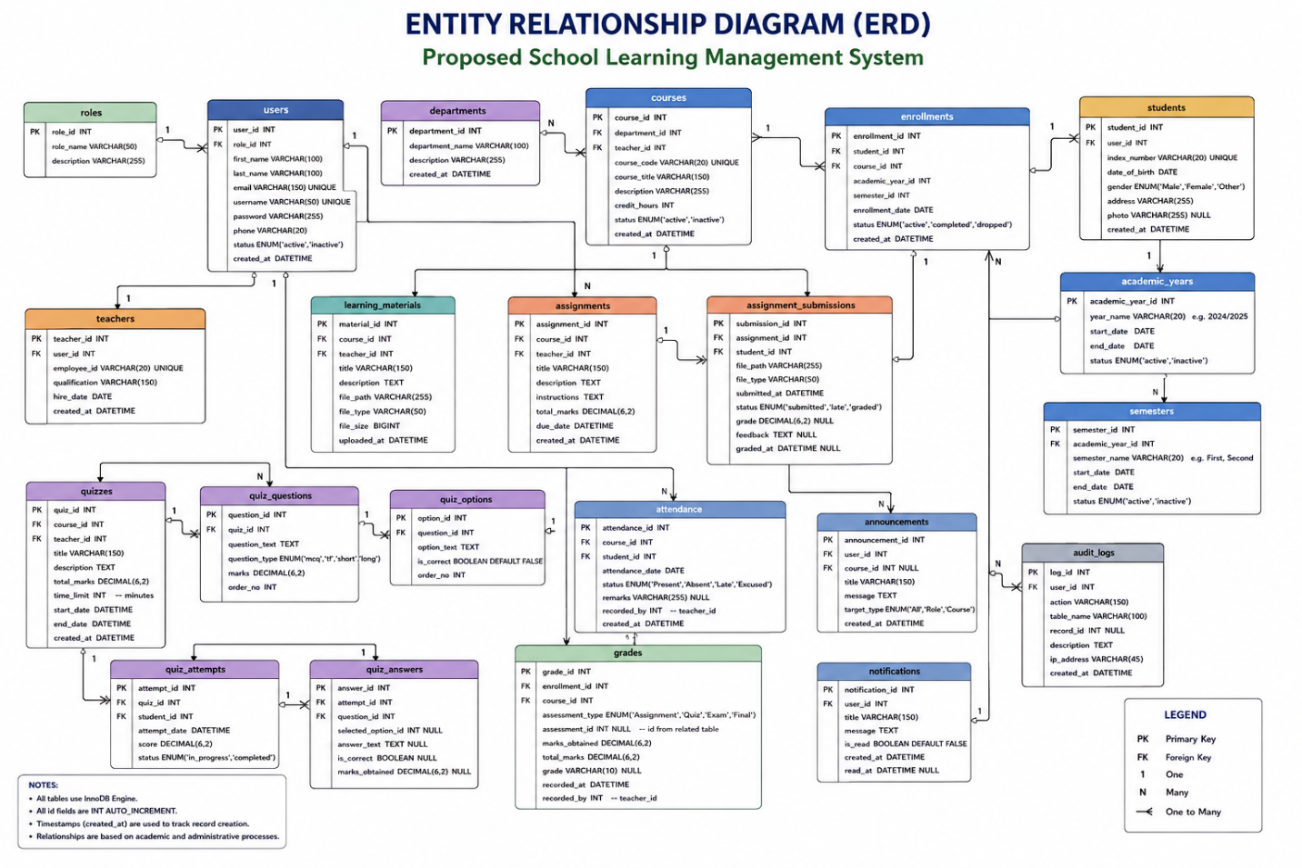
4.6 Data Dictionary
The data dictionary provides a detailed description of the major data elements used in the database of the proposed School Learning Management System. It defines the names, data types, and purposes of important fields used to store and manage information within the system. The data dictionary serves as a reference for understanding the structure of the database and the relationships among its major entities.
The dictionary is organised according to the major functional areas of the LMS, including user management, academic management, learning resources, assignments, assessments, attendance, results, communication, and system monitoring.
4.6.1 User and Security Tables
Table | Field | Data Type | Description
Users | user_id | INT | Unique identifier for a system user.
Users | username | VARCHAR | Unique username used to identify the user.
Users | password | VARCHAR | Securely stored user password hash.
Users | email | VARCHAR | User's email address.
Users | role_id | INT | Identifies the role assigned to the user.
Users | status | VARCHAR | Indicates whether the user account is active or inactive.
Roles | role_id | INT | Unique identifier for a user role.
Roles | role_name | VARCHAR | Name of the assigned system role.
Permissions | permission_id | INT | Unique identifier for a system permission.
Permissions | permission_name | VARCHAR | Defines an action that a user may perform.

4.6.2 Academic Management Tables
Table | Field | Data Type | Description
Departments | department_id | INT | Unique identifier for an academic department.
Departments | department_name | VARCHAR | Name of the academic department.
Academic_Years | academic_year_id | INT | Unique identifier for an academic year.
Academic_Years | year_name | VARCHAR | Name or description of the academic year.
Courses | course_id | INT | Unique identifier for a course.
Courses | course_code | VARCHAR | Unique code assigned to the course.
Courses | course_name | VARCHAR | Name of the course.
Courses | department_id | INT | Identifies the department responsible for the course.
Courses | teacher_id | INT | Identifies the teacher assigned to the course.

4.6.3 Student Enrolment Tables
Table | Field | Data Type | Description
Students | student_id | INT | Unique identifier for a student.
Students | user_id | INT | Links the student record to a user account.
Students | student_number | VARCHAR | Unique identification number assigned to the student.
Enrolments | enrolment_id | INT | Unique identifier for an enrolment record.
Enrolments | student_id | INT | Identifies the student being enrolled.
Enrolments | course_id | INT | Identifies the course in which the student is enrolled.
Enrolments | academic_year_id | INT | Identifies the relevant academic year.

4.6.4 Learning Material Tables
Table | Field | Data Type | Description
Materials | material_id | INT | Unique identifier for a learning material.
Materials | course_id | INT | Identifies the course associated with the material.
Materials | title | VARCHAR | Title of the learning material.
Materials | file_path | VARCHAR | Location of the uploaded material.
Materials | uploaded_by | INT | Identifies the user who uploaded the material.
Materials | created_at | DATETIME | Records when the material was uploaded.

4.6.5 Assignment Tables
Table | Field | Data Type | Description
Assignments | assignment_id | INT | Unique identifier for an assignment.
Assignments | course_id | INT | Identifies the course associated with the assignment.
Assignments | title | VARCHAR | Title of the assignment.
Assignments | description | TEXT | Instructions or description of the assignment.
Assignments | due_date | DATETIME | Specifies the assignment submission deadline.
Assignment_Submissions | submission_id | INT | Unique identifier for a submission.
Assignment_Submissions | assignment_id | INT | Identifies the assignment being submitted.
Assignment_Submissions | student_id | INT | Identifies the student submitting the assignment.
Assignment_Submissions | file_path | VARCHAR | Location of the submitted file.
Assignment_Submissions | grade | DECIMAL | Grade awarded for the submission.
Assignment_Submissions | feedback | TEXT | Feedback provided by the teacher.

4.6.6 Assessment and Quiz Tables
Table | Field | Data Type | Description
Quizzes | quiz_id | INT | Unique identifier for a quiz.
Quizzes | course_id | INT | Identifies the course associated with the quiz.
Quizzes | title | VARCHAR | Title of the quiz.
Quizzes | duration | INT | Duration allocated for completing the quiz.
Quiz_Questions | question_id | INT | Unique identifier for a quiz question.
Quiz_Questions | quiz_id | INT | Identifies the quiz containing the question.
Quiz_Questions | question_text | TEXT | Text of the quiz question.
Quiz_Submissions | submission_id | INT | Unique identifier for a quiz submission.
Quiz_Submissions | quiz_id | INT | Identifies the quiz attempted.
Quiz_Submissions | student_id | INT | Identifies the student attempting the quiz.
Quiz_Submissions | score | DECIMAL | Score obtained by the student.

4.6.7 Attendance Tables
Table | Field | Data Type | Description
Attendance | attendance_id | INT | Unique identifier for an attendance record.
Attendance | student_id | INT | Identifies the student whose attendance is recorded.
Attendance | course_id | INT | Identifies the course associated with the attendance record.
Attendance | attendance_date | DATE | Date on which attendance was recorded.
Attendance | status | VARCHAR | Indicates whether the student was present, absent, or otherwise recorded.

4.6.8 Results and Performance Tables
Table | Field | Data Type | Description
Results | result_id | INT | Unique identifier for an academic result.
Results | student_id | INT | Identifies the student associated with the result.
Results | course_id | INT | Identifies the course associated with the result.
Results | score | DECIMAL | Numerical score obtained by the student.
Results | grade | VARCHAR | Grade assigned based on the student's performance.
Grade_Categories | category_id | INT | Unique identifier for a grade category.
Grade_Categories | category_name | VARCHAR | Name of the grading category.

4.6.9 Communication and Notification Tables
Table | Field | Data Type | Description
Announcements | announcement_id | INT | Unique identifier for an announcement.
Announcements | title | VARCHAR | Title of the announcement.
Announcements | message | TEXT | Content of the announcement.
Announcements | created_by | INT | Identifies the user who created the announcement.
Notifications | notification_id | INT | Unique identifier for a notification.
Notifications | user_id | INT | Identifies the recipient of the notification.
Notifications | message | TEXT | Content of the notification.
Notifications | is_read | BOOLEAN | Indicates whether the notification has been read.

4.6.10 Audit and Activity Tables
Table | Field | Data Type | Description
Audit_Logs | audit_id | INT | Unique identifier for an audit record.
Audit_Logs | user_id | INT | Identifies the user who performed the activity.
Audit_Logs | action | VARCHAR | Describes the action performed by the user.
Audit_Logs | activity_time | DATETIME | Records the date and time of the activity.
Audit_Logs | ip_address | VARCHAR | Records the IP address associated with the activity where applicable.

The data dictionary provides a structured reference for the principal data elements used by the proposed Learning Management System. Primary keys uniquely identify records, while foreign keys establish relationships between related entities. The defined data elements support the implementation of the system's major modules and provide a consistent basis for storing, retrieving, and processing academic and administrative information.
4.7 Input Design
Input design describes how data is entered into the proposed School Learning Management System and how the system validates and processes the information before storing it in the database. The design aims to ensure that data entered by administrators, teachers, and students is accurate, complete, consistent, and appropriate for the intended operation.
The system provides role-specific input forms based on the responsibilities and permissions of each user. The major input areas include user management, academic management, learning materials, assignments, assessments, attendance, results, and communication.
4.7.1 Administrator Input
The Administrator provides information required for managing the overall operation of the LMS. Major administrator input forms include:
- User Registration Form: captures username, name, email address, password, role, and account status.
- Department Form: captures department name and other relevant departmental information.
- Course Form: captures course code, course name, department, teacher assignment, and related course information.
- Academic Session Form: captures academic year, semester, and session information.
- System Settings Form: captures configuration information required for system operation.
- Report Parameters allows administrators to specify criteria such as academic year, course, department, student, or date range when generating reports.
4.7.2 Teacher Input
Teachers provide information required for teaching, assessment, attendance, and student performance management. Major teacher input forms include:
- Course Management Form: captures and updates relevant course information.
- Learning Material Form: allows teachers to provide material titles, descriptions, associated courses, and upload files.
- Assignment Form: captures assignment title, description, course, instructions, maximum marks, and submission deadline.
- Quiz and Assessment Form: captures assessment details, questions, options, correct answers, marks, and other relevant settings.
- Attendance Form: records the attendance status of students for a selected course and date.
- Grading Form: allows teachers to enter marks, grades, and feedback for student submissions.
- Announcement Form: captures announcement titles, messages, target users, and related academic information.
4.7.3 Student Input
Students provide information primarily when participating in learning and assessment activities. Major student input forms include:
- Profile Form allows students to provide or update permitted personal information.
- Assignment Submission Form: allows students to upload completed assignments and provide required submission information.
- Quiz Input allows students to select or enter answers when completing online quizzes.
- Communication Input: allows students to send messages or other permitted academic communication.
- Feedback Input: allows students to provide feedback where the relevant system functionality is available.
4.7.4 Input Validation
Input validation is incorporated into the system to reduce incorrect, incomplete, or potentially harmful data. Validation is performed before information is processed or stored in the database.
The major validation mechanisms include:
- Required fields are checked to ensure that essential information is provided.
- Email addresses are validated using appropriate formats.
- Usernames and other unique identifiers are checked for duplication.
- Password requirements are enforced during account creation or password changes.
- Numerical fields are validated to ensure that appropriate numeric values are entered.
- Dates are validated to ensure that they follow the required format and logical constraints.
- Assignment deadlines are checked against relevant dates.
- Uploaded files are validated according to permitted file types and size restrictions.
- User permissions are checked before restricted operations are processed.
- Database queries use prepared statements to reduce the risk of SQL injection.
4.7.5 Input Processing
After successful validation, the submitted information is sent from the frontend to the appropriate RESTful API endpoint. The backend authenticates and authorises the request before processing the associated business logic. Where database interaction is required, the API performs the appropriate database operation and returns a JSON response to the frontend.
The general input processing sequence is:
User Input → Frontend Form → Validation → HTTP Request → REST API → Authentication/Authorisation → Business Logic → MySQL Database → JSON Response → Updated Interface
This approach ensures that data is processed through the appropriate application layer rather than allowing the frontend to communicate directly with the database.
4.7.6 Input Design Principles
The input interfaces are designed according to the following principles:
- Simplicity: Forms contain only information relevant to the operation being performed.
- Consistency: Similar forms use consistent labels, controls, buttons, and validation messages.
- Accuracy: Validation mechanisms reduce incorrect or invalid data entry.
- Security: Sensitive operations require appropriate authentication and authorisation.
- User feedback: The system displays success, warning, and error messages after user actions.
- Role-based access: Users are presented with input functions appropriate to their assigned roles.
- Usability: Forms are designed to support clear navigation and efficient data entry.
The input design therefore provides a controlled mechanism for capturing information from administrators, teachers, and students while ensuring that submitted data is validated, securely processed, and stored appropriately within the LMS database.
4.8 Output Design
Output design describes how information processed by the proposed School Learning Management System is presented to administrators, teachers, and students. The system converts information stored in the database into meaningful outputs such as dashboards, academic reports, grades, attendance records, notifications, and other system responses. The design aims to ensure that outputs are accurate, relevant, clearly presented, and accessible only to authorised users.
The major outputs of the proposed LMS are described below.
4.8.1 Administrator Outputs
The Administrator receives outputs that support academic and system management. These include:
- Administrator Dashboard: displays summaries of users, courses, departments, academic activities, and other relevant system statistics.
- User Reports: provides information about registered administrators, teachers, and students.
- Course Reports: presents course information, teacher assignments, and enrolment statistics.
- Academic Reports: provides student performance and other academic information based on selected criteria.
- Attendance Reports: summarises student attendance records for selected courses, classes, or periods.
- System Activity Reports: provides information about recorded user and system activities.
- Audit Logs displays relevant activities performed by users for monitoring and accountability.
- Notifications: informs administrators about relevant system and academic events.
4.8.2 Teacher Outputs
Teachers receive outputs that support teaching, assessment, attendance, and student performance management. These include:
- Teacher Dashboard: provides an overview of assigned courses, students, assignments, assessments, and other teaching activities.
- Course Information: displays course details and enrolled students.
- Learning Material Status: displays uploaded materials and their associated courses.
- Assignment Submissions: provides a list of student submissions and their submission status.
- Grading Results: displays grades and feedback recorded for student submissions.
- Attendance Reports: presents attendance records for students enrolled in a teacher's courses.
- Student Performance Reports: provides information about student academic performance.
- Quiz and Assessment Results: displays student scores and assessment outcomes.
- Announcements: displays published academic announcements and their recipients.
4.8.3 Student Outputs
Students receive outputs that provide access to learning resources and academic information. These include:
- Student Dashboard: displays enrolled courses, pending assignments, upcoming assessments, notifications, and other relevant academic information.
- Course Information: displays courses in which the student is enrolled.
- Learning Materials provides access to available course materials.
- Assignment Information: displays assignment descriptions, deadlines, submission status, grades, and feedback.
- Quiz Results displays scores and relevant assessment outcomes after completion.
- Attendance Information: allows students to view their recorded attendance where permitted.
- Academic Results: displays grades and other available performance information.
- Notifications: displays announcements, academic reminders, and other relevant system notifications.
4.8.4 System Messages and API Responses
In addition to dashboards and reports, the system generates immediate responses following user actions. These responses inform users whether an operation was successful or whether an error occurred.
Examples include:
- Successful login messages.
- Invalid login notifications.
- Successful record creation messages.
- Validation error messages.
- Successful assignment submission messages.
- File upload notifications.
- Access-denied messages.
- Database or server error messages.
- Successful update and deletion confirmations.
The backend returns these responses to the frontend through the RESTful API using JSON. The frontend interprets the response and presents an appropriate message or updated information to the user.
4.8.5 Report Generation
The LMS provides report outputs based on information stored in the centralised database. Reports may be generated according to relevant criteria such as student, course, department, academic year, or date range.
Major report categories include:
Report | Main User | Purpose
Student Performance Report | Administrator, Teacher | Shows student academic performance.
Attendance Report | Administrator, Teacher | Summarises student attendance.
Course Report | Administrator, Teacher | Provides course and enrolment information.
Assignment Report | Teacher, Administrator | Shows assignment submission and grading information.
Assessment Report | Teacher, Administrator | Presents assessment results and performance.
User Report | Administrator | Provides information about system users.
Activity Report | Administrator | Provides information about recorded system activities.

4.8.6 Output Design Principles
The outputs of the system are designed according to the following principles:
- Accuracy: Information displayed to users should reflect the data stored and processed by the system.
- Clarity: Outputs should be presented using clear labels, tables, cards, and appropriate visual elements.
- Relevance: Users should receive information relevant to their roles and activities.
- Security: Sensitive academic information should only be accessible to authorised users.
- Consistency: Reports, dashboards, messages, and other outputs should follow a consistent interface design.
- Timeliness: System responses and updated information should be provided promptly after successful processing.
- Usability: Outputs should be easy to read, understand, and navigate.
The output design therefore ensures that information generated by the LMS is presented in a structured and user-friendly manner. By providing role-specific dashboards, reports, academic results, notifications, and system responses, the proposed system enables administrators, teachers, and students to access relevant information efficiently.
4.9 User Interface (UI) Design
The User Interface (UI) design of the proposed School Learning Management System focuses on providing a simple, consistent, responsive, and user-friendly environment through which administrators, teachers, and students can interact with the system. The interface is designed according to the roles and responsibilities of users, ensuring that each user is presented with the functions and information relevant to their activities.
The UI is implemented using HTML5, CSS3, JavaScript, and Bootstrap. The use of responsive design principles enables the system interface to adapt to different screen sizes and devices, including desktop computers, laptops, tablets, and mobile devices.
4.9.1 Administrator Interface
The Administrator interface provides access to the major administrative functions of the LMS. The administrator dashboard presents an overview of important system information and provides navigation to the available management modules.
The major administrator interface components include:
- Dashboard: displays summaries of users, courses, departments, academic activities, and system statistics.
- User Management: provides interfaces for creating, viewing, updating, and managing user accounts.
- Department Management: provides forms for creating and managing academic departments.
- Course Management: allows administrators to create, update, view, and manage courses.
- Academic Session Management: provides interfaces for managing academic years and sessions.
- Reports: provides access to academic, attendance, course, and system reports.
- Audit Logs allows administrators to review recorded system activities.
- System Settings: provides access to permitted system configuration options.
4.9.2 Teacher Interface
The Teacher interface is designed to support teaching, learning, assessment, and student management activities. The teacher dashboard provides access to assigned courses and the functions required to manage academic activities.
The major teacher interface components include:
- Dashboard: provides an overview of courses, students, assignments, assessments, and notifications.
- Course Management: allows teachers to access and manage assigned courses.
- Learning Materials provides interfaces for uploading, viewing, updating, and managing learning materials.
- Assignments: allows teachers to create assignments, specify deadlines, view submissions, and provide grades and feedback.
- Quizzes and Assessments provides interfaces for creating and managing online assessments.
- Attendance: allows teachers to record and view student attendance.
- Grades: provides interfaces for entering and viewing student grades and performance.
- Announcements: allows teachers to publish relevant academic information and notifications.
4.9.3 Student Interface
The student interface provides students with access to learning resources and academic activities. The dashboard presents relevant information such as enrolled courses, assignments, assessments, grades, attendance, and notifications.
The major student interface components include:
- Dashboard: displays an overview of the student's academic activities.
- Courses: provides access to enrolled courses.
- Learning Materials allows students to view or download available course materials.
- Assignments: displays assignment details, deadlines, submission status, grades, and feedback.
- Quizzes: provides access to available online quizzes and assessments.
- Attendance: allows students to view available attendance information.
- Grades: provides access to academic results and performance information.
- Notifications: displays announcements, reminders, and other relevant academic notifications.
4.9.4 Navigation Design
The navigation structure is designed to provide users with direct access to the functions available within their roles. The interface uses consistent navigation elements such as menus, dashboard cards, buttons, tables, forms, and navigation links.
Role-based navigation ensures that users do not receive menu options for functions that they are not authorised to perform. For example, administrative functions are presented to administrators, teaching and assessment functions are provided to teachers, and learning-related functions are provided to students.
4.9.5 Form Design
Forms are used throughout the system to capture and update information. The forms are designed with clear labels, appropriate input controls, validation messages, and action buttons.
Examples include:
- Login forms.
- User registration and management forms.
- Course forms.
- Learning material upload forms.
- Assignment creation forms.
- Assignment submission forms.
- Quiz and assessment forms.
- Attendance forms.
- Grading forms.
- Announcement forms.
Input validation provides immediate feedback when required information is missing or incorrectly entered.
4.9.6 Table and Data Display Design
Tables are used to display structured information such as users, courses, students, assignments, submissions, attendance records, grades, notifications, and reports.
The table design provides:
- Clear column headings.
- Appropriate data formatting.
- Search and filtering where applicable.
- Pagination for large datasets where implemented.
- Action controls based on user permissions.
- Responsive presentation on smaller screens.
This design enables users to locate and manage records efficiently.
4.9.7 Responsive Design
The interface uses responsive design principles to support different screen sizes. Layouts, forms, navigation elements, tables, and dashboard components are designed to adapt to the available screen dimensions.
The responsive interface allows users to access the LMS through supported desktop and mobile browsers without requiring a separate application for each device type.
4.9.8 UI Feedback and Error Handling
The interface provides feedback after users perform system operations. Success messages are displayed when an operation is completed successfully, while validation and error messages are displayed when an operation cannot be completed.
Examples include:
- Successful login confirmation.
- Invalid login notification.
- Successful record creation message.
- Validation error message.
- Successful file upload notification.
- Assignment submission confirmation.
- Access-denied message.
- Server or API error notification.
This feedback helps users understand the outcome of their actions and reduces uncertainty when interacting with the system.
4.9.9 UI Design Principles
The proposed LMS interface follows the following principles:
- Consistency: similar functions use consistent layouts, controls, labels, and navigation.
- Simplicity: interfaces avoid unnecessary elements and present only relevant information.
- Usability: users can perform common activities with minimal steps.
- Responsiveness: interfaces adapt to different screen sizes.
- Accessibility: text, controls, and navigation are presented in a clear and understandable manner.
- Security: restricted functions and sensitive information are displayed only to authorised users.
- Feedback: the system provides clear responses to user actions.
- Role-based presentation: each user receives an interface appropriate to their assigned role.
The UI design therefore provides a consistent interaction environment for administrators, teachers, and students. The combination of role-based navigation, responsive layouts, structured forms, data tables, dashboards, and feedback mechanisms supports efficient interaction with the proposed Learning Management System.
Figure 4.4 presents representative interfaces for the Login page.
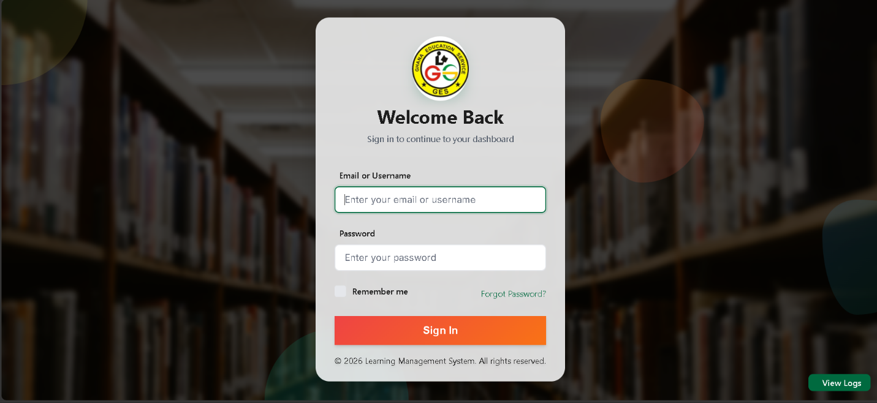
Figure 4.5 presents representative interfaces for the Forgot Password page.

Figure 4.6 presents representative interfaces for the Administrator dashboard.
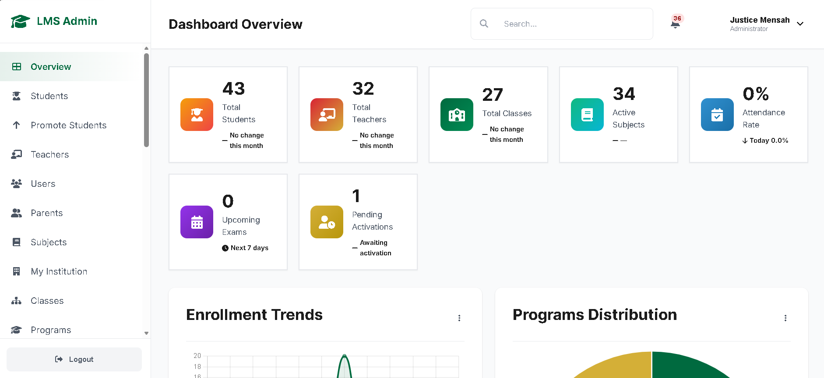
Figure 4.7 presents representative interfaces for the Teacher dashboard.
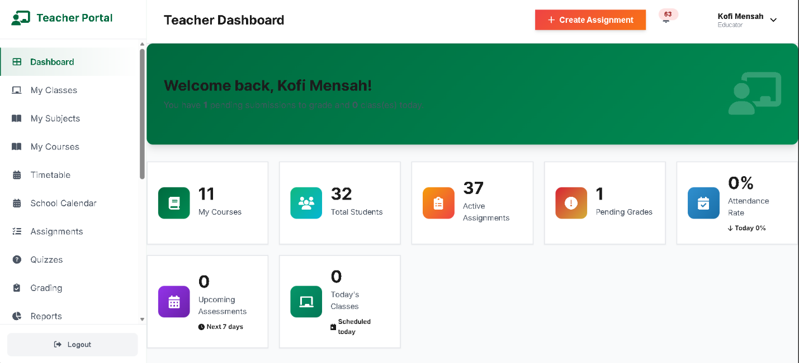
Figure 4.8 presents representative interfaces for the student dashboard.
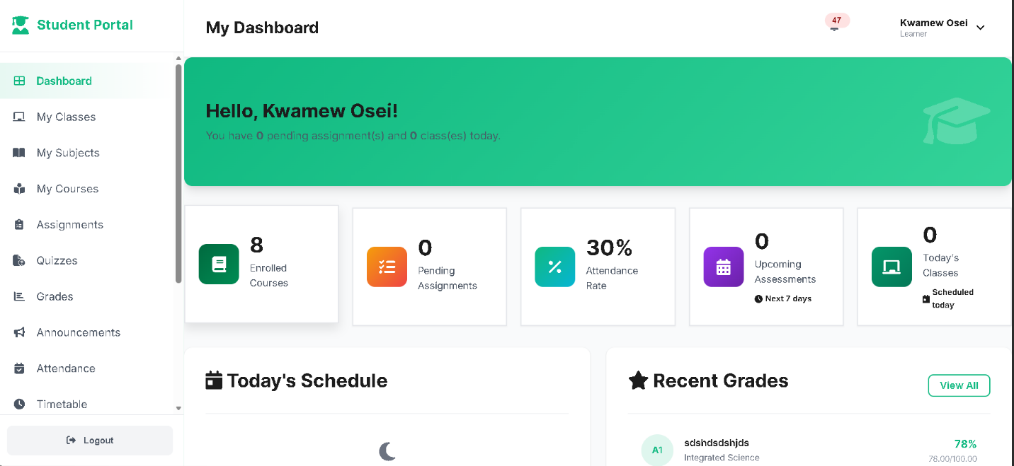

4.10 System Modules
The proposed School Learning Management System is organised into several interconnected modules. Each module is responsible for a specific set of academic or administrative functions while communicating with other modules through the backend RESTful API. This modular structure improves system organisation, maintainability, and separation of responsibilities.
The major modules implemented in the proposed system are described below.
4.10.1 Authentication and Security Module
The Authentication and Security Module controls access to the Learning Management System. It ensures that only authenticated and authorised users can access protected system functions.
The module is responsible for:
- User login and logout.
- Authentication of user credentials.
- Password management.
- Session management.
- Role-based access control.
- Authorisation of protected operations.
- Access restriction based on user roles.
- Recording relevant authentication and security activities.
The module ensures that administrators, teachers, and students are provided with access appropriate to their assigned roles.
4.10.2 User Management Module
The User Management Module allows administrators to manage accounts used to access the system. It provides centralised management of user information and account status.
The module supports:
- Creating user accounts.
- Viewing user information.
- Updating user accounts.
- Deactivating or managing account status.
- Assigning user roles.
- Managing permitted user information.
- Searching and filtering user records where implemented.
The module helps maintain consistent user information within the centralised database.
4.10.3 Academic Management Module
The Academic Management Module manages the academic structure of the institution. It provides administrators with tools for managing departments, courses, academic years, sessions, and related academic information.
The module supports:
- Department management.
- Course creation and management.
- Course code and course information management.
- Teacher-course assignment.
- Academic year management.
- Academic session management.
- Management of relevant academic records.
This module provides the foundation for organising the academic activities handled by the LMS.
4.10.4 Enrolment Management Module
The Enrolment Management Module manages the relationship between students and courses. It records the courses in which students are enrolled and provides information required for learning and assessment activities.
The module supports:
- Student enrolment.
- Course enrolment records.
- Viewing enrolled students.
- Viewing student course information.
- Maintaining relationships between students and courses.
The enrolment information is used by other modules such as assignments, attendance, assessments, and results.
4.10.5 Learning Material Module
The Learning Material Module provides a centralised platform for managing digital learning resources. Teachers can upload materials associated with their courses, while authorised students can access available resources.
The module supports:
- Uploading learning materials.
- Associating materials with courses.
- Viewing available materials.
- Downloading permitted materials.
- Updating material information.
- Managing material records.
Centralising learning materials reduces dependence on separate file-sharing platforms and makes course resources easier to access.
4.10.6 Assignment Management Module
The Assignment Management Module supports the creation, distribution, submission, and grading of assignments.
Teachers can:
- Create assignments.
- Provide assignment descriptions and instructions.
- Set submission deadlines.
- Specify marks or grading information.
- View student submissions.
- Grade submitted assignments.
- Provide feedback.
Students can:
- View available assignments.
- View assignment instructions and deadlines.
- Submit completed assignments.
- View submission status.
- View grades and feedback where available.
4.10.7 Quiz and Assessment Module
The Quiz and Assessment Module supports online assessments and quizzes. It enables teachers to create assessments and students to complete them through the LMS.
The module supports:
- Creating quizzes.
- Creating quiz questions.
- Defining available answers and correct responses where applicable.
- Setting assessment parameters.
- Publishing assessments.
- Student quiz attempts.
- Recording assessment responses.
- Calculating or recording scores.
- Viewing assessment results.
The module provides a structured approach to conducting online assessments.
4.10.8 Attendance Management Module
The Attendance Management Module enables teachers to record and manage student attendance for courses and academic activities.
The module supports:
- Recording attendance.
- Selecting courses and relevant dates.
- Recording student attendance status.
- Viewing attendance records.
- Monitoring attendance information.
- Generating attendance-related information and reports.
The centralised attendance records make it easier to retrieve and monitor student participation.
4.10.9 Results and Grading Module
The Results and Grading Module manages student academic performance information. It provides functions for recording, processing, and presenting grades and results.
The module supports:
- Recording student marks.
- Recording grades.
- Associating results with students and courses.
- Viewing student performance.
- Providing academic result information.
- Supporting generation of performance reports.
The module ensures that academic performance information is stored centrally and can be retrieved by authorised users.
4.10.10 Communication and Notification Module
The Communication and Notification Module supports communication between authorised users of the LMS. It provides a centralised mechanism for distributing academic announcements and system notifications.
The module supports:
- Creating announcements.
- Publishing academic information.
- Sending notifications.
- Displaying notifications to users.
- Tracking notification status where implemented.
- Supporting relevant user communication.
The module reduces dependence on fragmented communication channels and helps ensure that important academic information reaches the intended users.
4.10.11 Reporting Module
The Reporting Module converts stored academic and administrative data into useful reports for authorised users.
The module supports reports relating to:
- Student performance.
- Attendance.
- Courses.
- Assignments.
- Assessments.
- Users.
- Academic activities.
- Other available system information.
Administrators and authorised teachers can use reports to support monitoring, decision-making, and academic management.
4.10.12 Audit and Activity Monitoring Module
The Audit and Activity Monitoring Module records relevant activities performed within the system. It supports monitoring, accountability, and investigation of system activities.
The module can record information such as:
- User performing an activity.
- Action performed.
- Date and time of the activity.
- Relevant system operation.
- IP address where applicable.
Administrators can use audit information to monitor system usage and identify potentially unauthorised or unusual activities.
4.10.13 Module Integration
Although the LMS is divided into separate modules, the modules operate as an integrated system. For example, the Authentication Module determines whether a user can access the system, while the User Management Module determines the user's role and account information. The Enrolment Module provides course relationships used by the Learning Material, Assignment, Assessment, Attendance, and Results modules.
Communication between the frontend and these modules is handled through the RESTful API. The API processes requests, applies authentication and authorisation rules, performs the required business logic, communicates with the MySQL database, and returns JSON responses to the frontend.
The overall relationship between the major modules can therefore be represented as:
User → Authentication → Role-Based Dashboard → Relevant Module → REST API → MySQL Database → JSON Response → User Interface
The modular design enables the proposed Learning Management System to provide integrated academic and administrative services while maintaining clear separation of responsibilities among the different functional components.
4.11 Technologies
The development of the proposed School Learning Management System involved a combination of web development, server-side, database, API, and development tools. The selected technologies were chosen to support the requirements of the system, including maintainability, usability, security, data management, and communication between the frontend and backend.
4.11.1 HTML5
HTML5 was used to structure the content and components of the LMS user interface. It provides the basic structure for pages, forms, tables, navigation elements, dashboards, and other interface components.
HTML5 supports the organisation of information into meaningful elements, making the interface easier to develop and maintain.
4.11.2 CSS3
CSS3 was used to control the visual presentation and layout of the system. It was applied to elements such as colours, typography, spacing, buttons, forms, tables, navigation menus, and dashboard components.
CSS3 also supports responsive layouts, allowing the interface to adapt to different screen sizes and devices.
4.11.3 JavaScript
JavaScript was used to provide client-side functionality and dynamic interaction within the LMS. It enables the frontend to respond to user actions, validate information, manipulate interface elements, and communicate with backend services.
JavaScript also supports asynchronous communication with the REST API, allowing data to be retrieved or submitted without requiring complete page reloads.
4.11.4 Bootstrap
Bootstrap was used as a frontend framework to support responsive and consistent interface development. It provides reusable components and layout utilities for elements such as navigation bars, forms, buttons, cards, tables, alerts, and responsive grids.
The use of Bootstrap helps maintain consistency across the different user interfaces of the LMS.
4.11.5 PHP 8
PHP 8 was used for the server-side implementation of the system. It processes requests received from the frontend, performs business logic, validates data, communicates with the database, and generates API responses.
PHP was selected because it provides suitable support for web application development and integrates effectively with MySQL and Apache.
4.11.6 RESTful API
The system uses a RESTful Application Programming Interface (API) to facilitate communication between the frontend and backend. The API provides endpoints through which the frontend can request, create, update, or delete system information.
The API architecture separates the presentation layer from the backend services and allows the frontend to communicate with the application using standard HTTP methods such as:
- GET – retrieves information.
- POST – creates or submits information.
- PUT/PATCH – updates existing information.
- DELETE – removes information where authorised.
This architecture supports the API-first design of the proposed LMS.
4.11.6.1 API Endpoint Documentation
The proposed School Learning Management System uses RESTful API endpoints to provide communication between the frontend application and the PHP backend. The frontend sends HTTP requests through the Fetch API, while the backend authenticates and authorises requests, validates input, performs the required business operations, communicates with the MySQL database, and returns JSON responses.
The API follows standard HTTP methods. GET requests are used to retrieve resources, POST requests are used to create or submit resources, PUT or PATCH requests are used to update existing resources, and DELETE requests are used to remove resources where the operation is authorised. This approach is consistent with the API-first architecture specified in Chapter Three.
The principal API endpoints are documented below.
Table 4.1: Authentication API Endpoints
Method | Endpoint | Purpose | Authentication | Access
POST | /api/auth/login | Authenticates a user and establishes an authenticated session | No | All users
POST | /api/auth/logout | Terminates the authenticated user session | Yes | Authenticated users

The login endpoint receives the user's authentication credentials, verifies the supplied password against the stored password hash, identifies the user's role, and establishes the authenticated session. The logout endpoint terminates the active session.
Table 4.2: User Management API Endpoints
Method | Endpoint | Purpose | Authentication | Access
GET | /api/users | Retrieves user records | Yes | Administrator
POST | /api/users | Creates a new user account | Yes | Administrator
PUT/PATCH | /api/users/{id} | Updates user information | Yes | Administrator
DELETE | /api/users/{id} | Removes or deactivates a user where supported | Yes | Administrator

The user management endpoints allow authorised administrators to maintain user accounts. Role-based authorisation prevents teachers and students from accessing administrative user-management operations.
Table 4.3: Course API Endpoints
Method | Endpoint | Purpose | Authentication | Access
GET | /api/courses | Retrieves available courses | Yes | Administrator, Teacher, Student
POST | /api/courses | Creates a course | Yes | Administrator/Authorised Teacher
PUT/PATCH | /api/courses/{id} | Updates course information | Yes | Administrator/Authorised Teacher
DELETE | /api/courses/{id} | Deletes or archives a course where supported | Yes | Administrator/Authorised Teacher

The course endpoints provide controlled access to course information and ensure that only authorised users can create or modify academic course records.
Table 4.4: Learning Material API Endpoints
Method | Endpoint | Purpose | Authentication | Access
GET | /api/materials | Retrieves learning materials | Yes | Administrator, Teacher, Student
POST | /api/materials | Uploads or creates a learning material record | Yes | Teacher
PUT/PATCH | /api/materials/{id} | Updates material information | Yes | Teacher
DELETE | /api/materials/{id} | Deletes or archives learning material where supported | Yes | Teacher/Administrator

Learning material endpoints allow teachers to publish educational resources and authorised students to access materials associated with their courses.
Table 4.5: Assignment API Endpoints
Method | Endpoint | Purpose | Authentication | Access
GET | /api/assignments | Retrieves available assignments | Yes | Administrator, Teacher, Student
POST | /api/assignments | Creates an assignment | Yes | Teacher
PUT/PATCH | /api/assignments/{id} | Updates assignment information | Yes | Teacher
DELETE | /api/assignments/{id} | Removes an assignment where authorised | Yes | Teacher/Administrator
POST | /api/assignments/{id}/submissions | Submits student assignment work | Yes | Student
GET | /api/assignments/{id}/submissions | Retrieves assignment submissions | Yes | Teacher

The assignment endpoints support the complete assignment workflow, from creation by teachers to submission by students and subsequent review by authorised teachers.
Table 4.6: Quiz and Assessment API Endpoints
Method | Endpoint | Purpose | Authentication | Access
GET | /api/quizzes | Retrieves available quizzes | Yes | Administrator, Teacher, Student
POST | /api/quizzes | Creates a quiz | Yes | Teacher
PUT/PATCH | /api/quizzes/{id} | Updates quiz information | Yes | Teacher
DELETE | /api/quizzes/{id} | Removes a quiz where authorised | Yes | Teacher
POST | /api/quizzes/{id}/attempts | Submits a quiz attempt | Yes | Student
GET | /api/quizzes/{id}/results | Retrieves quiz results | Yes | Teacher/Student according to permissions

The quiz endpoints support online assessment activities and ensure that students can submit attempts while teachers can manage assessments and review results.
Table 4.7: Grade API Endpoints
Method | Endpoint | Purpose | Authentication | Access
GET | /api/grades | Retrieves authorised grade records | Yes | Teacher/Student
POST | /api/grades | Records a grade | Yes | Teacher
PUT/PATCH | /api/grades/{id} | Updates a grade | Yes | Teacher/Administrator
GET | /api/grades/student/{id} | Retrieves a student's academic results | Yes | Authorised users

The grade endpoints provide controlled access to academic performance information. Teachers can record and update grades, while students can view their own authorised results.
Table 4.8: Attendance API Endpoints
Method | Endpoint | Purpose | Authentication | Access
GET | /api/attendance | Retrieves attendance records | Yes | Teacher/Student
POST | /api/attendance | Records attendance | Yes | Teacher
PUT/PATCH | /api/attendance/{id} | Updates an attendance record | Yes | Teacher
GET | /api/attendance/student/{id} | Retrieves student attendance information | Yes | Authorised users

The attendance endpoints enable teachers to record student attendance and allow authorised users to retrieve relevant attendance information.
4.11.6.2 API Request and Response Format
The API uses JSON for communication between the frontend and backend. A typical request contains the information required to perform the requested operation, while the response contains the operation status, message, relevant data, HTTP status information, and timestamp where applicable.
A successful response follows a structure similar to:
{
"success": true,
"message": "Operation completed successfully",
"data": {},
"meta": {
"timestamp": "2026-08-09T00:00:00Z"
}
}
An unsuccessful request returns an appropriate HTTP status code together with an error message. For example:
{
"success": false,
"error": {
"code": "VALIDATION_ERROR",
"message": "Invalid request data"
},
"meta": {
"timestamp": "2026-08-09T00:00:00Z"
}
}
The use of a consistent JSON structure allows the JavaScript frontend to process successful and unsuccessful API responses uniformly.
4.11.6.3 API Authentication and Authorisation
Protected API endpoints require an authenticated user session before the requested operation can be processed. After authentication, the user's role and permissions are used to determine whether the requested operation is permitted.
For example, an administrator may create users and generate reports, a teacher may create assignments and record attendance, while a student may submit assignments and view authorised grades. This role-based access model is consistent with the functional requirements and RBAC design described in Chapter Three.
4.11.6.4 API Testing
The API endpoints were designed to be independently testable using Postman. Testing involves sending HTTP requests with valid and invalid inputs and verifying the HTTP status code, JSON response, validation behaviour, authentication requirements, authorisation rules, and database operation.
The API testing process includes:
- Testing valid authentication requests.
- Testing invalid authentication credentials.
- Testing authorised and unauthorised requests.
- Testing GET, POST, PUT/PATCH, and DELETE operations.
- Testing required-field validation.
- Testing invalid data types and values.
- Testing database creation, retrieval, updating, and deletion.
- Verifying JSON response structures.
- Verifying appropriate HTTP status codes.
- Testing role-based access restrictions.
This API documentation provides a direct link between the system architecture, functional requirements, implementation modules, and system testing. The endpoints documented here should correspond exactly to the routes implemented in the PHP backend.
4.11.7 JSON
JavaScript Object Notation (JSON) is used as the primary data-interchange format between the frontend and backend API.
The API returns information and operation results in JSON format, which JavaScript can process and use to update the user interface. JSON provides a lightweight and structured format for exchanging information between the frontend and backend.
4.11.8 Fetch API
The Fetch API is used within the JavaScript frontend to send HTTP requests to the RESTful API and process responses.
For example, when a user submits a form, JavaScript can use the Fetch API to send the information to the appropriate PHP API endpoint. The API processes the request and returns a JSON response, which the frontend uses to provide feedback or update displayed information.
The communication process can be represented as:
Frontend → Fetch API → REST API → PHP → MySQL → JSON Response → Frontend
4.11.9 MySQL
MySQL was used as the relational database management system for the LMS. It provides centralised storage for user, academic, learning, assessment, attendance, results, communication, and system activity information.
MySQL supports relational database concepts such as primary keys, foreign keys, constraints, and relationships, which are important for maintaining the integrity and consistency of the LMS data.
4.11.10 Apache
Apache HTTP Server provides the web server environment required to run the PHP-based backend of the system. It receives web requests and allows the PHP application and REST API services to be accessed through the configured server environment.
4.11.11 XAMPP
XAMPP was used as the local development environment for the system. It provides an integrated environment containing components such as Apache and MySQL, allowing the LMS to be developed and tested locally.
XAMPP simplifies the configuration of the development environment and provides the infrastructure required to run the PHP application and database during development.
4.11.12 Visual Studio Code
Visual Studio Code (VS Code) was used as the primary source-code editor during system development. It provided an environment for creating and managing the HTML, CSS, JavaScript, PHP, and other project files.
Its development features support code editing, project organisation, debugging, and integration with version-control tools.
4.11.13 Git
Git was used as the version-control system for managing changes made to the source code. It allows different versions of the project to be tracked and provides a mechanism for maintaining the development history.
Git also makes it possible to revert changes when necessary and supports structured software development.
4.11.14 GitHub
GitHub was used as a remote repository for storing and managing the project's source code. It provides version-control collaboration capabilities and serves as a backup location for the project repository.
The repository also supports tracking changes and managing different development versions of the LMS.
4.11.15 Postman
Postman was used to test and validate the RESTful API endpoints during development. API requests could be sent directly to individual endpoints to verify authentication, data processing, database operations, validation, and JSON responses.
Postman was particularly useful for testing backend services independently from the frontend.
4.11.16 Summary of Technologies
Technology/Tool | Purpose in the System
HTML5 | Structures the web interface.
CSS3 | Provides styling, layout, and responsive presentation.
JavaScript | Provides client-side interaction and dynamic functionality.
Bootstrap | Supports responsive layouts and reusable interface components.
PHP 8 | Implements server-side processing and REST API services.
REST API | Provides communication between the frontend and backend.
JSON | Exchanges structured data between the frontend and API.
Fetch API | Sends asynchronous HTTP requests from the frontend.
MySQL | Stores and manages system data.
Apache | Provides the web server environment for the PHP application.
XAMPP | Provides the local development and testing environment.
Visual Studio Code | Provides the development and source-code editing environment.
Git | Tracks and manages source-code changes.
GitHub | Hosts and manages the project's remote repository.
Postman | Tests and validates REST API endpoints.

The combination of these technologies provides the technical foundation for implementing the proposed School Learning Management System. The frontend technologies provide the user interface, PHP and the RESTful API provide application services, MySQL provides persistent data storage, and the supporting development tools facilitate development, testing, and version control.
4.12 System Testing
System testing was conducted to verify that the proposed School Learning Management System functions according to the specified requirements and that the major components operate correctly as an integrated system. Testing was performed after the development of the major system modules and focused on functionality, integration, security, usability, and reliability.
The testing process involved checking individual system components, interactions between the frontend, RESTful API and database, complete system workflows, and the ability of users to perform their assigned activities. The major testing approaches applied were unit testing, integration testing, system testing, and user acceptance testing.
4.12.1 Unit Testing
Unit testing was used to verify individual functions and components of the system independently. The purpose was to identify errors within specific functions before they were integrated with other components.
Examples of components tested include:
- User authentication functions.
- User registration and validation.
- Course creation and updating.
- Learning material upload.
- Assignment creation.
- Assignment submission.
- Attendance recording.
- Grade processing.
- Notification processing.
- API request validation.
Each function was tested using valid and invalid inputs to determine whether it produced the expected result.
4.12.2 Integration Testing
Integration testing was performed to verify communication between different components of the LMS. Attention was given to the interaction between the frontend, RESTful API, authentication and authorisation mechanisms, business logic, and MySQL database.
The following interactions were tested:
Frontend → REST API
The system was tested to ensure that requests submitted through the frontend were correctly sent to the appropriate API endpoints.
REST API → Database
API operations were tested to ensure that data could be correctly inserted, retrieved, updated, and deleted from the MySQL database where authorised.
Database → REST API → Frontend
Responses returned from the database through the API were tested to ensure that the correct information was converted into JSON and displayed appropriately on the frontend.
Integration testing also verified that authentication and role-based permissions were correctly applied when users attempted to access protected resources.
4.12.3 System Testing
System testing evaluated the LMS as a complete integrated application. Rather than testing individual components separately, the entire system was tested according to typical user workflows.
The major system workflows tested included:
- Authentication Workflow
A user enters login credentials, the system validates the credentials, determines the user's role, and redirects the user to the appropriate dashboard.
- Course Management Workflow
An authorised administrator or teacher creates or updates course information, the API processes the request, and the information is stored in the MySQL database.
- Learning Material Workflow
A teacher uploads learning material, the system validates the request and file information, stores the relevant record, and makes the material available to authorised students.
- Assignment Workflow
A teacher creates an assignment, students access the assignment and submit their work, and the teacher reviews, grades, and provides feedback on the submission.
- Attendance Workflow
A teacher selects a course and records student attendance. The system validates and stores the attendance information and makes appropriate records available to authorised users.
- Assessment Workflow
A teacher creates an assessment or quiz, students complete the assessment, and the system records the resulting information.
- Results Workflow
Student marks and grades are processed and stored, after which authorised, users can view the relevant academic performance information.
- Communication Workflow
Administrators or teachers publish announcements or notifications, which are then made available to the intended users.
System testing therefore verified that the major modules operate together as a single integrated LMS.
4.12.4 Security Testing
Security-related tests were performed to verify that access to protected functions and information was appropriately restricted.
The testing included:
- Testing valid and invalid login credentials.
- Verifying role-based access control.
- Attempting to access restricted functions using an unauthorised role.
- Testing input validation.
- Testing protected API endpoints.
- Verifying that users cannot directly access functions outside their permissions.
- Testing database operations using controlled inputs.
- Checking appropriate handling of authentication and session information.
The purpose of security testing was to ensure that sensitive academic and user information was protected from unauthorised access and inappropriate system operations.
4.12.5 User Acceptance Testing
User Acceptance Testing (UAT) was used to determine whether the LMS satisfies the functional expectations of its intended users. The testing focused on common tasks performed by administrators, teachers, and students.
Administrators were expected to test functions such as:
- Logging into the system.
- Managing users.
- Managing departments and courses.
- Managing academic sessions.
- Generating reports.
- Reviewing system activities.
Teachers were expected to test functions such as:
- Accessing assigned courses.
- Uploading learning materials.
- Creating assignments and assessments.
- Recording attendance.
- Grading student work.
- Publishing announcements.
Students were expected to test functions such as:
- Logging into the system.
- Accessing enrolled courses.
- Viewing learning materials.
- Submitting assignments.
- Taking available assessments.
- Viewing grades and academic information.
- Receiving notifications.
Feedback from these activities was used to identify interface, functionality, and usability issues requiring correction.
4.12.6 Testing Criteria
The system was considered to have passed a test when the actual result matched the expected result, and the operation did not produce an unacceptable error.
The following criteria were considered:
Criterion | Description
Functional correctness | The system performs the requested operation correctly.
Data integrity | Information is stored and retrieved accurately.
Access control | Users can access only authorised functions.
API communication | Frontend requests and backend responses operate correctly.
Error handling | Invalid operations produce appropriate error messages.
Usability | Users can complete common tasks without unnecessary difficulty.
Reliability | The system performs consistently during repeated operations.
Responsiveness | The interface operates appropriately across supported screen sizes.

The results of the individual test cases are presented in Section 4.13, where the test scenarios, expected results, actual results, and test status are documented.
Overall, system testing provided evidence that the major components of the proposed Learning Management System were tested individually and collectively. The testing process helped identify and correct functional, integration, security, and usability issues before the system was considered ready for deployment and user evaluation.
4.13 Test Cases
Test cases were developed to verify that the major functions of the proposed School Learning Management System operate according to the specified requirements. Each test case defines the function being tested, the input or action performed, the expected result, the actual result, and the status of the test.
The test cases cover authentication, user management, course management, learning materials, assignments, assessments, attendance, results, notifications, access control, and API communication.
4.13.1 Authentication Test Cases
Test ID | Test Case | Test Input/Action | Expected Result | Actual Result | Status
TC-001 | Valid Login | Enter valid username and password | User is authenticated and redirected to the appropriate dashboard | User was authenticated and redirected correctly | Pass
TC-002 | Invalid Login | Enter incorrect username/password | Error message is displayed and access is denied | Error message was displayed | Pass
TC-003 | Empty Login Fields | Submit login form without credentials | Validation message is displayed | Validation message was displayed | Pass
TC-004 | Role-Based Access | Login using different user roles | User receives access according to assigned role | Role-based access worked correctly | Pass
TC-005 | Logout | Select logout | User session is terminated and login page is displayed | Session was terminated successfully | Pass

4.13.2 User Management Test Cases
Test ID | Test Case | Test Input/Action | Expected Result | Actual Result | Status
TC-006 | Create User | Enter valid user information | New user account is created | User account was created | Pass
TC-007 | Duplicate User | Enter an existing username/email | System rejects duplicate information | Duplicate information was rejected | Pass
TC-008 | Update User | Modify existing user information | User record is updated | User record was updated | Pass
TC-009 | Invalid User Data | Submit incomplete user information | Validation message is displayed | Validation message was displayed | Pass

4.13.3 Course Management Test Cases
Test ID | Test Case | Test Input/Action | Expected Result | Actual Result | Status
TC-010 | Create Course | Enter valid course details | Course is created and stored | Course was created successfully | Pass
TC-011 | Update Course | Modify course information | Course information is updated | Course was updated | Pass
TC-012 | View Course | Select a course | Correct course information is displayed | Course information was displayed | Pass
TC-013 | Invalid Course Data | Submit incomplete course information | Validation error is displayed | Validation error was displayed | Pass

4.13.4 Learning Material Test Cases
Test ID | Test Case | Test Input/Action | Expected Result | Actual Result | Status
TC-014 | Upload Material | Upload a valid learning material | Material is uploaded and associated with the selected course | Material was uploaded successfully | Pass
TC-015 | Invalid File | Upload an unsupported file type | System rejects the file | File was rejected | Pass
TC-016 | View Material | Student selects available material | Material information is displayed | Material was displayed | Pass
TC-017 | Download Material | Student selects download | Authorised material is downloaded | Material was downloaded successfully | Pass

4.13.5 Assignment Test Cases
Test ID | Test Case | Test Input/Action | Expected Result | Actual Result | Status
TC-018 | Create Assignment | Teacher enters assignment details | Assignment is created | Assignment was created successfully | Pass
TC-019 | View Assignment | Student opens an assignment | Assignment details and deadline are displayed | Details were displayed | Pass
TC-020 | Submit Assignment | Student uploads valid assignment | Submission is recorded | Submission was recorded successfully | Pass
TC-021 | Grade Assignment | Teacher enters grade and feedback | Grade and feedback are saved | Grade and feedback were saved | Pass
TC-022 | Invalid Submission | Submit an invalid or unsupported file | System rejects the submission | Submission was rejected | Pass

4.13.6 Attendance Test Cases
Test ID | Test Case | Test Input/Action | Expected Result | Actual Result | Status
TC-023 | Record Attendance | Teacher records student attendance | Attendance record is stored | Record was stored successfully | Pass
TC-024 | View Attendance | Select course/date | Correct attendance records are displayed | Records were displayed | Pass
TC-025 | Invalid Attendance Data | Submit incomplete attendance information | Validation message is displayed | Validation message was displayed | Pass

4.13.7 Assessment and Results Test Cases
Test ID | Test Case | Test Input/Action | Expected Result | Actual Result | Status
TC-026 | Create Quiz | Teacher enters valid quiz information | Quiz is created | Quiz was created successfully | Pass
TC-027 | Attempt Quiz | Student answers quiz questions | Answers are submitted successfully | Answers were submitted successfully | Pass
TC-028 | Record Score | Complete assessment | Score is calculated or recorded correctly | Score was recorded correctly | Pass
TC-029 | View Grade | Student opens results | Authorised grade information is displayed | Grade was displayed correctly | Pass

4.13.8 Communication and Notification Test Cases
Test ID | Test Case | Test Input/Action | Expected Result | Actual Result | Status
TC-030 | Create Announcement | Teacher/admin enters announcement | Announcement is published | Announcement was published | Pass
TC-031 | View Notification | User opens notifications | Relevant notification is displayed | Notification was displayed | Pass
TC-032 | Mark Notification Read | User opens notification | Notification status is updated | Status was updated | Pass

4.13.9 Security and Access Control Test Cases
Test ID | Test Case | Test Input/Action | Expected Result | Actual Result | Status
TC-033 | Unauthorised Page Access | Student attempts to access an administrator function | Access is denied | Access was denied | Pass
TC-034 | Protected API Request | Send request without valid authentication | API rejects the request | Request was rejected | Pass
TC-035 | Role Permission | Teacher attempts to perform an administrator-only operation | Operation is denied | Operation was denied | Pass
TC-036 | Input Validation | Submit invalid data to an API endpoint | Request is rejected with an appropriate response | Invalid request was rejected | Pass

4.13.10 API and Database Test Cases
Test ID | Test Case | Test Input/Action | Expected Result | Actual Result | Status
TC-037 | GET Request | Request valid course data | API returns the requested data in JSON format | JSON response was returned | Pass
TC-038 | POST Request | Submit valid course information | API creates the record and returns a response | Record was created successfully | Pass
TC-039 | UPDATE Request | Submit valid updated information | Existing record is updated | Record was updated successfully | Pass
TC-040 | DELETE Request | Delete an authorised record | Record is removed or appropriately deactivated | Operation completed successfully | Pass
TC-041 | Database Retrieval | Request stored student information | Correct database records are returned | Correct records were returned | Pass

4.13.11 Summary of Test Results
The test cases covered the major functional and technical components of the proposed LMS. The results indicate that the tested functions performed according to their expected behaviour. Authentication, role-based access control, user management, academic management, learning materials, assignments, attendance, assessments, results, communication, API operations, and database interactions were tested.
The testing results provide evidence that the proposed system can support the major academic and administrative activities for which it was designed. Any errors identified during development were corrected and the relevant functions were retested before the system was considered ready for user evaluation.
4.14 Summary
This chapter presented the design and development structure of the proposed School Learning Management System. The system design was developed based on the requirements and challenges identified during the analysis of the existing academic management processes.
The chapter described the proposed system design, system architecture, use case design, database design, data dictionary, input design, and output design. The database design established the structure for storing and managing users, departments, courses, enrolments, learning materials, assignments, assessments, attendance, results, notifications, and system activities. The input and output designs described how information is entered into the system, validated, processed, stored, and presented to authorised users.
The chapter also described the major system modules, including authentication and security, user management, academic management, enrolment, learning materials, assignments, assessments, attendance, results, communication, reporting, and audit monitoring. The technologies used to implement the system, including HTML5, CSS3, JavaScript, Bootstrap, PHP 8, RESTful API, JSON, Fetch API, MySQL, Apache, XAMPP, Git, GitHub, and Postman, were also discussed.
System testing was presented through different testing approaches, including unit testing, integration testing, system testing, security testing, and user acceptance testing. Test cases were developed to verify major system functions such as authentication, user management, course management, learning materials, assignments, attendance, assessments, results, notifications, API operations, database interactions, and role-based access control. The testing results indicated that the major functions of the proposed system performed according to their expected behaviour.
Overall, the chapter established the technical and functional design of the proposed School Learning Management System and provided the foundation for its implementation and evaluation. The design integrates the major academic and administrative processes into a centralised web-based platform intended to improve efficiency, accessibility, data management, communication, and security within the institution.

